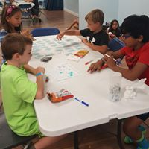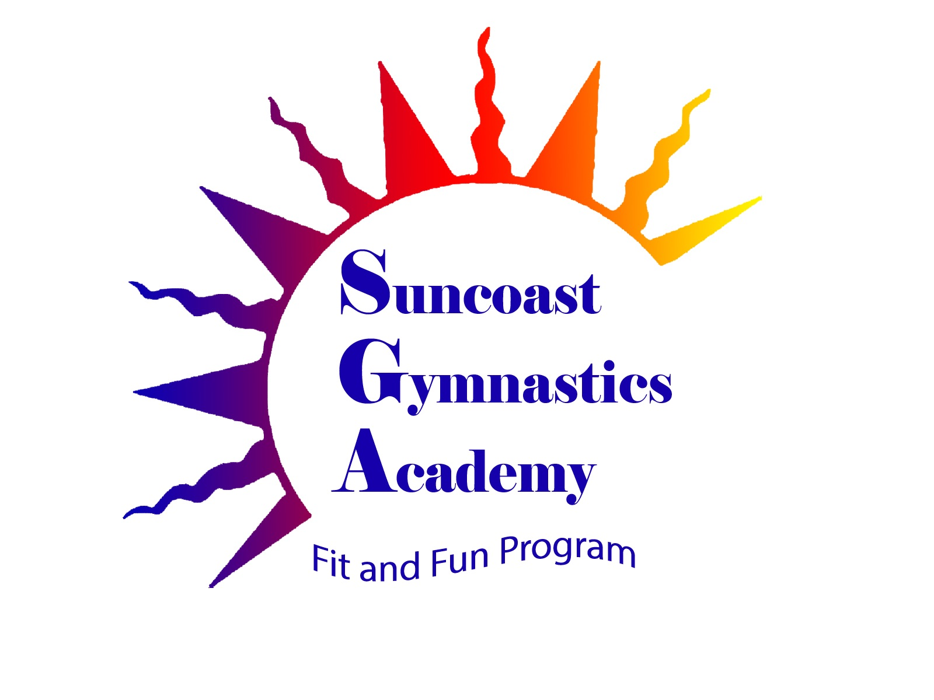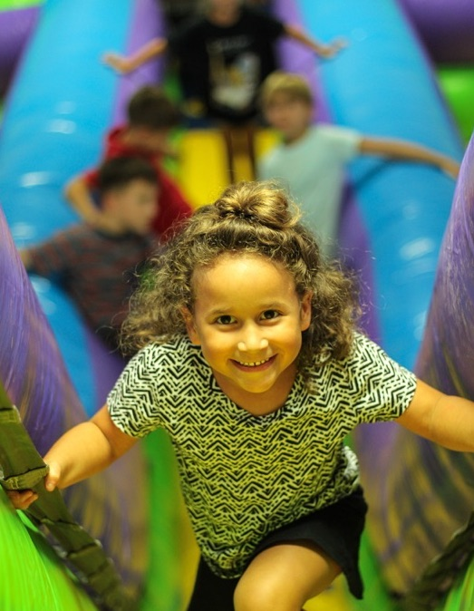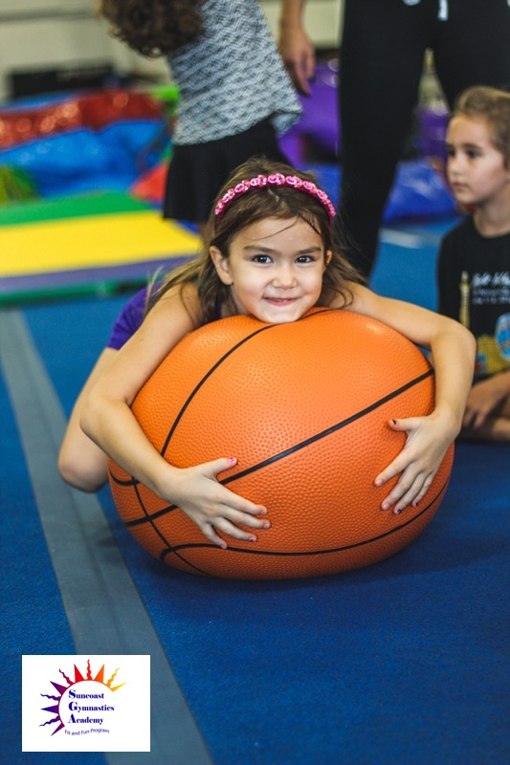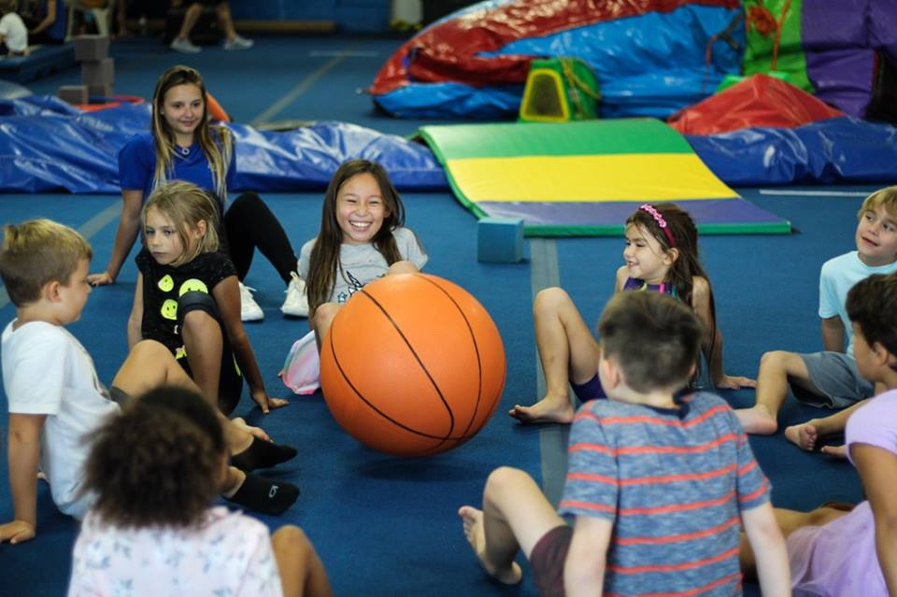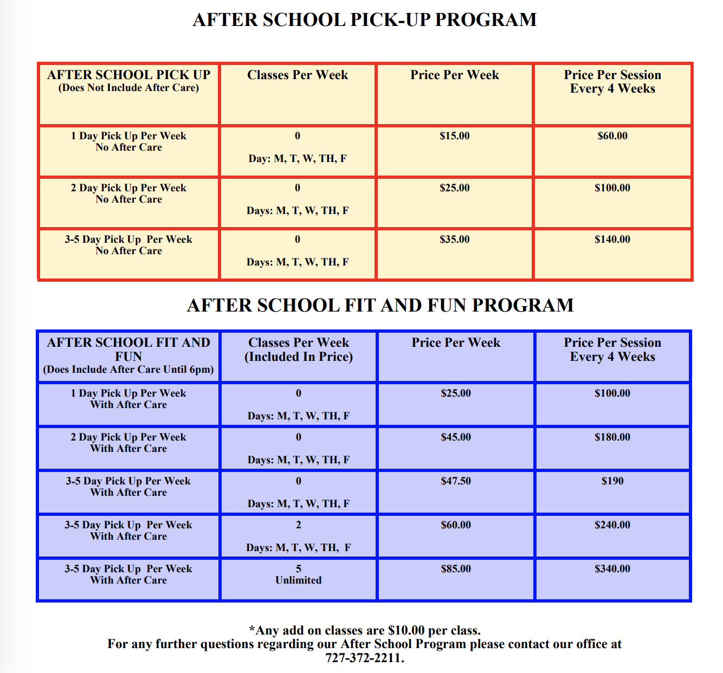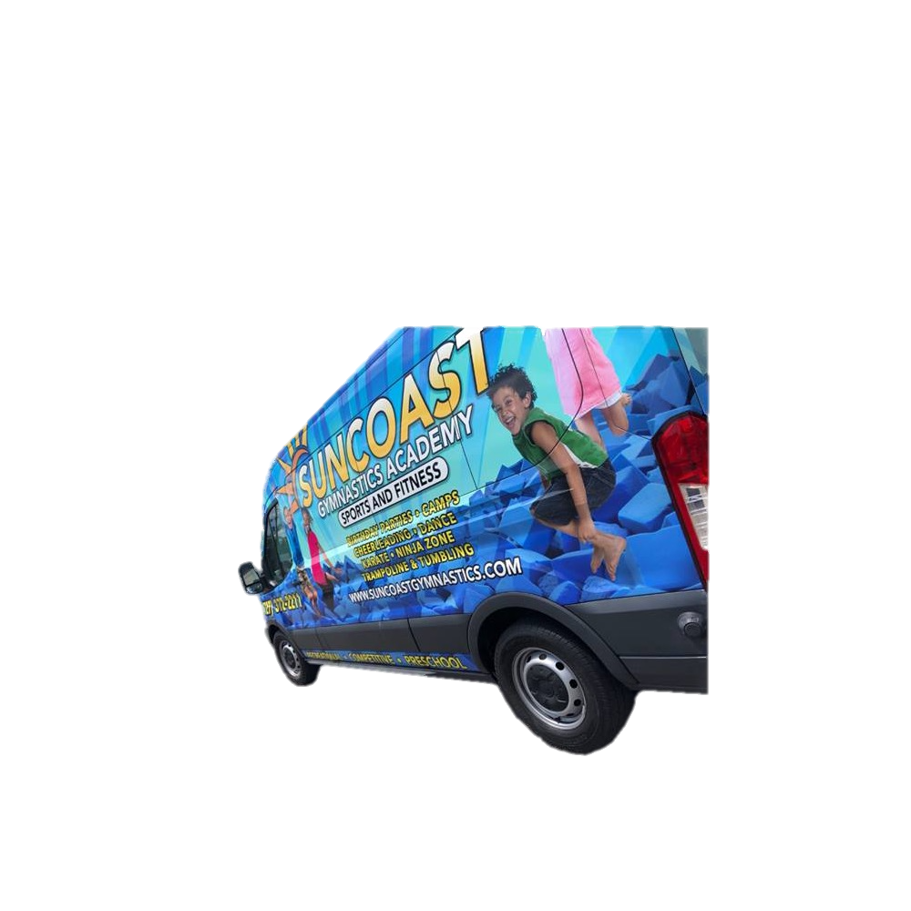

**After-School Fit and Fun Program!**

11131 Cargo Ct. 33556 Odessa Fl.

727-372-2211

**Information**

* Finish homework with help from a tutor
* Jump and slide down inflatables!
* Play games out of our game book
* Enroll in classes throughout the week
* Stay fit while having fun!
* Activities will never stop during the day!
* Snack provided after school!

*ASK OUR FRONT DESK OR VISIT OUR WEBSITE TO COMPLETE A REGISTRATION PACKET!*

Prices may vary depending on the amount of classes your athlete is planning on participating in!

Website:

http://suncoastgymnastics.com/programs/after-school-fit-and-fun-program

Phone:

727-372-2211

Register soon for next year to ensure your child’s seat in our bus! Time to have an amazing school year full of energy, academics, and sports!

**Registration!**

School, Fitness, and Fun!

**Contact our front desk or download a Registration packet online!**

**PRICES AND SCHEDULE OF PICK-UP**

**The fun doesn’t have to end when school does! Suncoast Gymnastics offers a fun and unique After School program, which allows children to stay fit while having fun.**

**When the children arrive from school they will have down time for snacks and homework, these athletes will have the ability to utilize our inflatables, floor space, hundreds of games, and more!**

**Athletes will be able to enroll in any of our program classes such as Recreational Boys and Girls Gymnastics, Trampoline and Tumbling, Cheer, Tumbling, Acrobatic Gymnastics, Ninja Zone, and Dance!**

**What is After-School Fit and Fun?!**