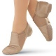
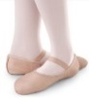
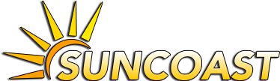
Suncoast Dance Academy Dress Code
Tap/Ballet Combo Classes
Females: Any color leotard, tights, tan tap shoes, pink leather ballet shoes. Ballet skirts are allowed. Hair must be in a ponytail, or bun.
Males: Black tap shoes and black ballet shoes.
Ballet/Jazz Combo Classes
Females: Any color leotard, tights, pink leather ballet shoes and tan jazz shoes. Ballet skirts and fitted dance shorts are allowed. Hair must be in a ponytail, or bun.
Males: Black ballet and black jazz shoes.
Tap Classes
Females: Any color leotard, tights, and tan tap shoes. Ballet skirts and fitted dance shorts are allowed. Hair must be in a ponytail, or bun.
Males: Black tap shoes.
Ballet Classes
Females: Any color leotard, tights, and pink leather ballet shoes. Ballet skirts are allowed. Hair must be in a ponytail, or bun.
Males: Black ballet shoes.
Hip Hop Classes
Comfortable clothing that allows you to move and stretch freely. Tennis shoes, or barefoot. Please have hair pulled back out of your face.

Visit our online dance store to buy dance shoes, leotards, shorts, skirts, tights, and other dance items.
Students can be fitted for dance shoes by their instructor before you place your order. This assures the correct size shoe is ordered every time.

www.shopnimbly.com/suncoastdance

Dance Academy

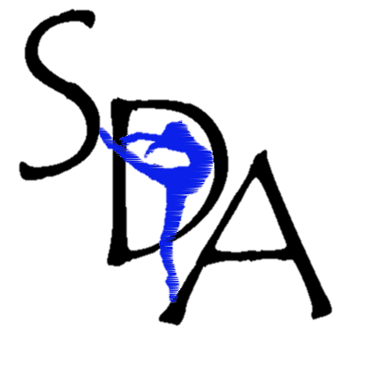
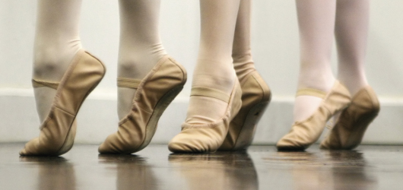

11131 Cargo Ct Odessa Florida
727-372-2211

Dance@Suncoastgymnastics.com

Dance Classes

Each dance class will work on dance vocabulary and technique every week while gradually building and adding skills.

Students will begin learning their recital dance in January, but will continue to focus on technique throughout the year.

In order to maximize individual attention for each student, each class has a limit of how many students can attend. Sign up today before spaces fill!

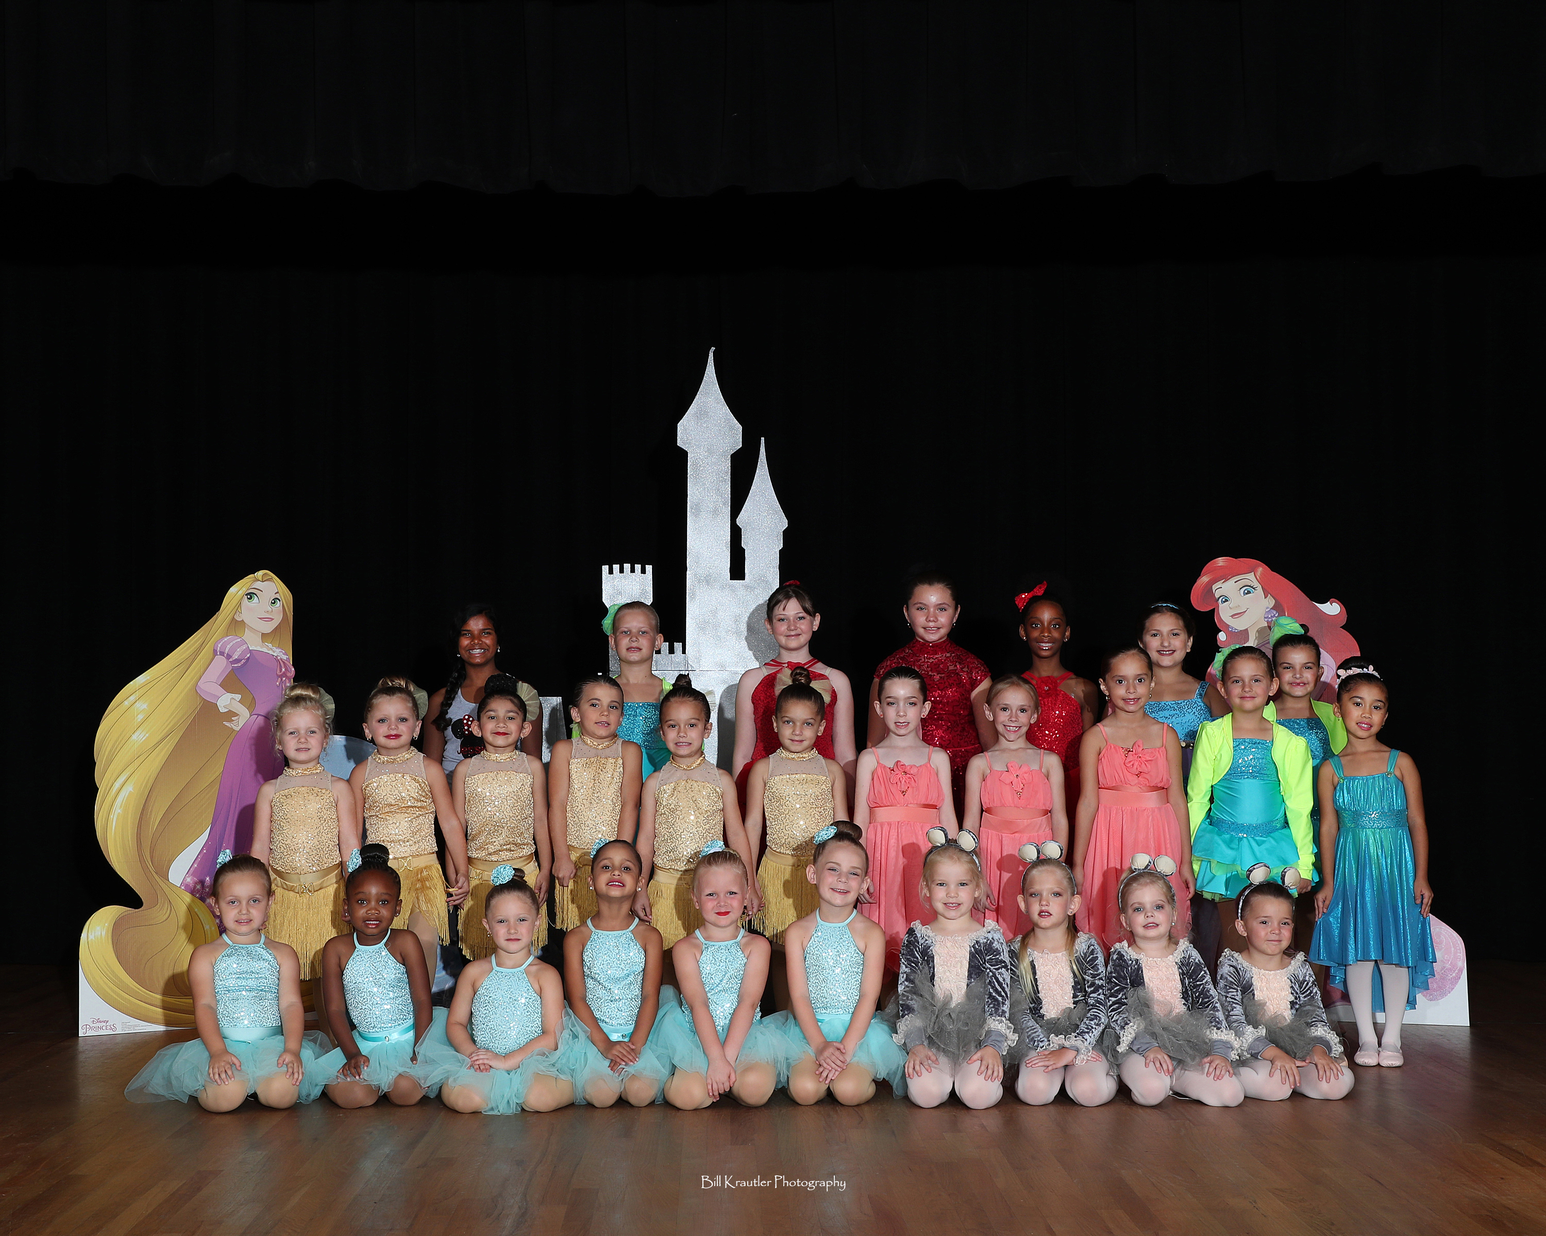

Recital:

All classes are invited to perform.

in our annual June recital. All students participating must attend the rehearsal and purchase a costume. Costume fees include the costume, accessories, and tights. Each costume is priced around $70-$95.

Rehearsal and recital details will be released in the spring.

At Suncoast Dance Academy, we are committed to quality dance education in a positive and safe learning environment.

Parents can expect open communication, a professional environment, and respect for each child.
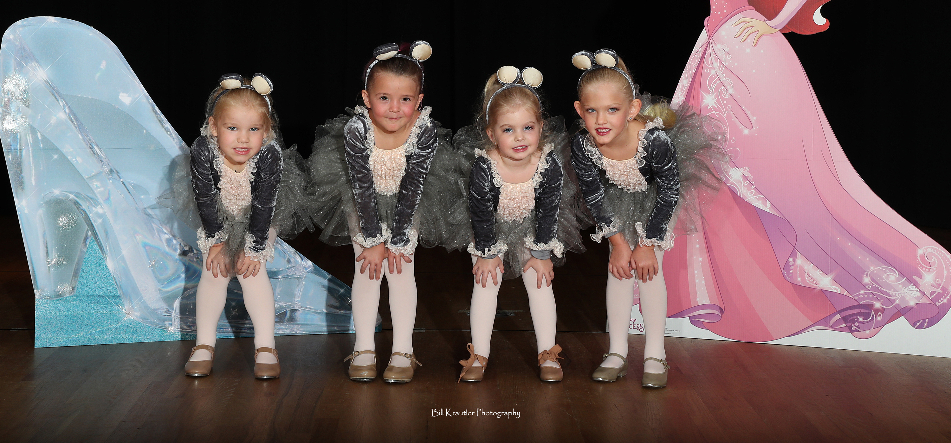

Every student is important to us, each deserving to be treated as an individual.
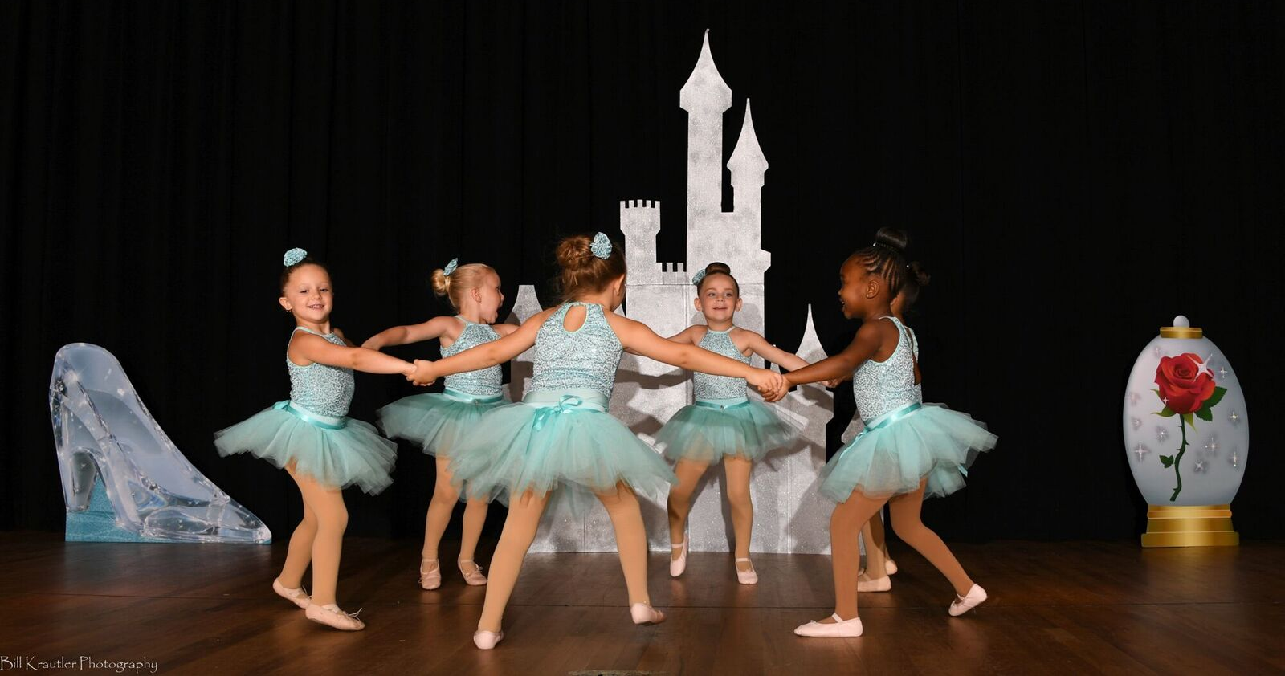

Each student will be given the opportunity to grow, whether he/she is a recreational dancer or a serious student with dreams of a performance career.
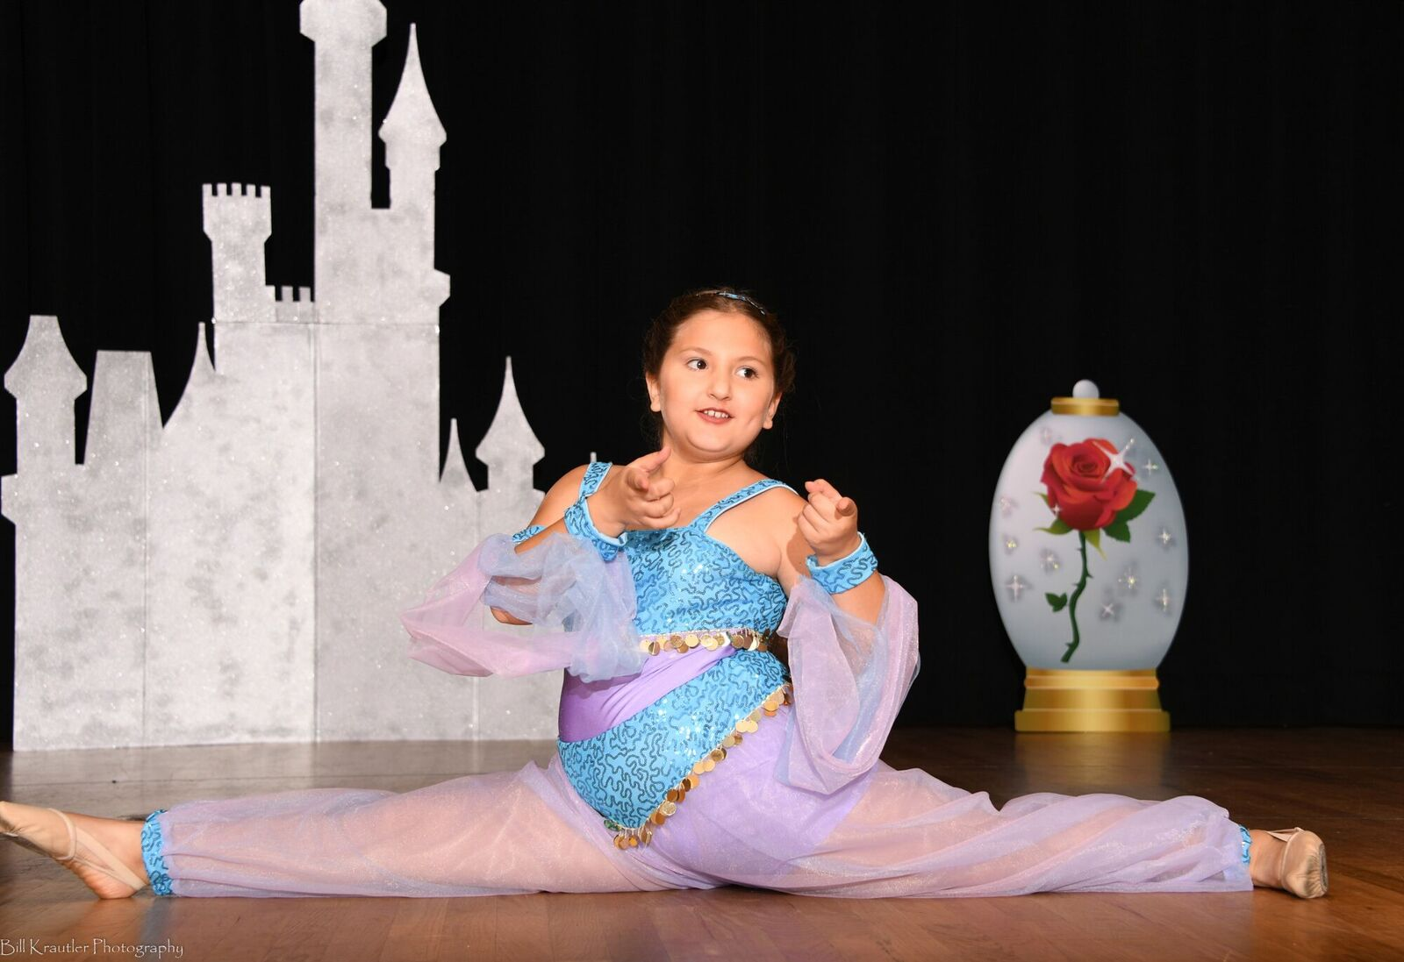

Above all, our students should learn to appreciate and love the art of dance and leave each class feeling good about him/herself.

Suncoast Dance Academy

Curriculum

Bitty Combo (2-3)
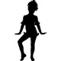
Bitty Combo classes are 30 minute classes that teach the basics of tap and ballet. Students will work on developing listening skills, gross motor development, cognitive skills, rhythm, coordination, dance vocabulary and dance technique.

Tap/Ballet Combo Classes (3 years+)
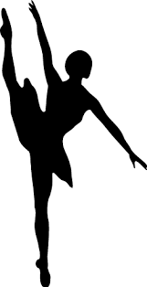
Combo Classes are 60 minute classes that teach basic through advanced level skills of Tap, Jazz, and Ballet. The combo classes teach discipline, commitment, and self-respect through work at the Barre, in center, and dance games.

Ballet/Jazz Combo Classes (8 years+)
Ballet/Jazz Combo Classes are 60 minute classes that teach basic through advanced Ballet and Jazz. These classes stress the importance of discipline, commitment, and dance technique. Students will learn at the barre, center floor, and through dance games.
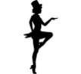
Tap
A graded system of Barre, center, and progressive techniques emphasizing speed and clarity of sound and rhythm. Tap is the music of rhythmic sound made by the feet.
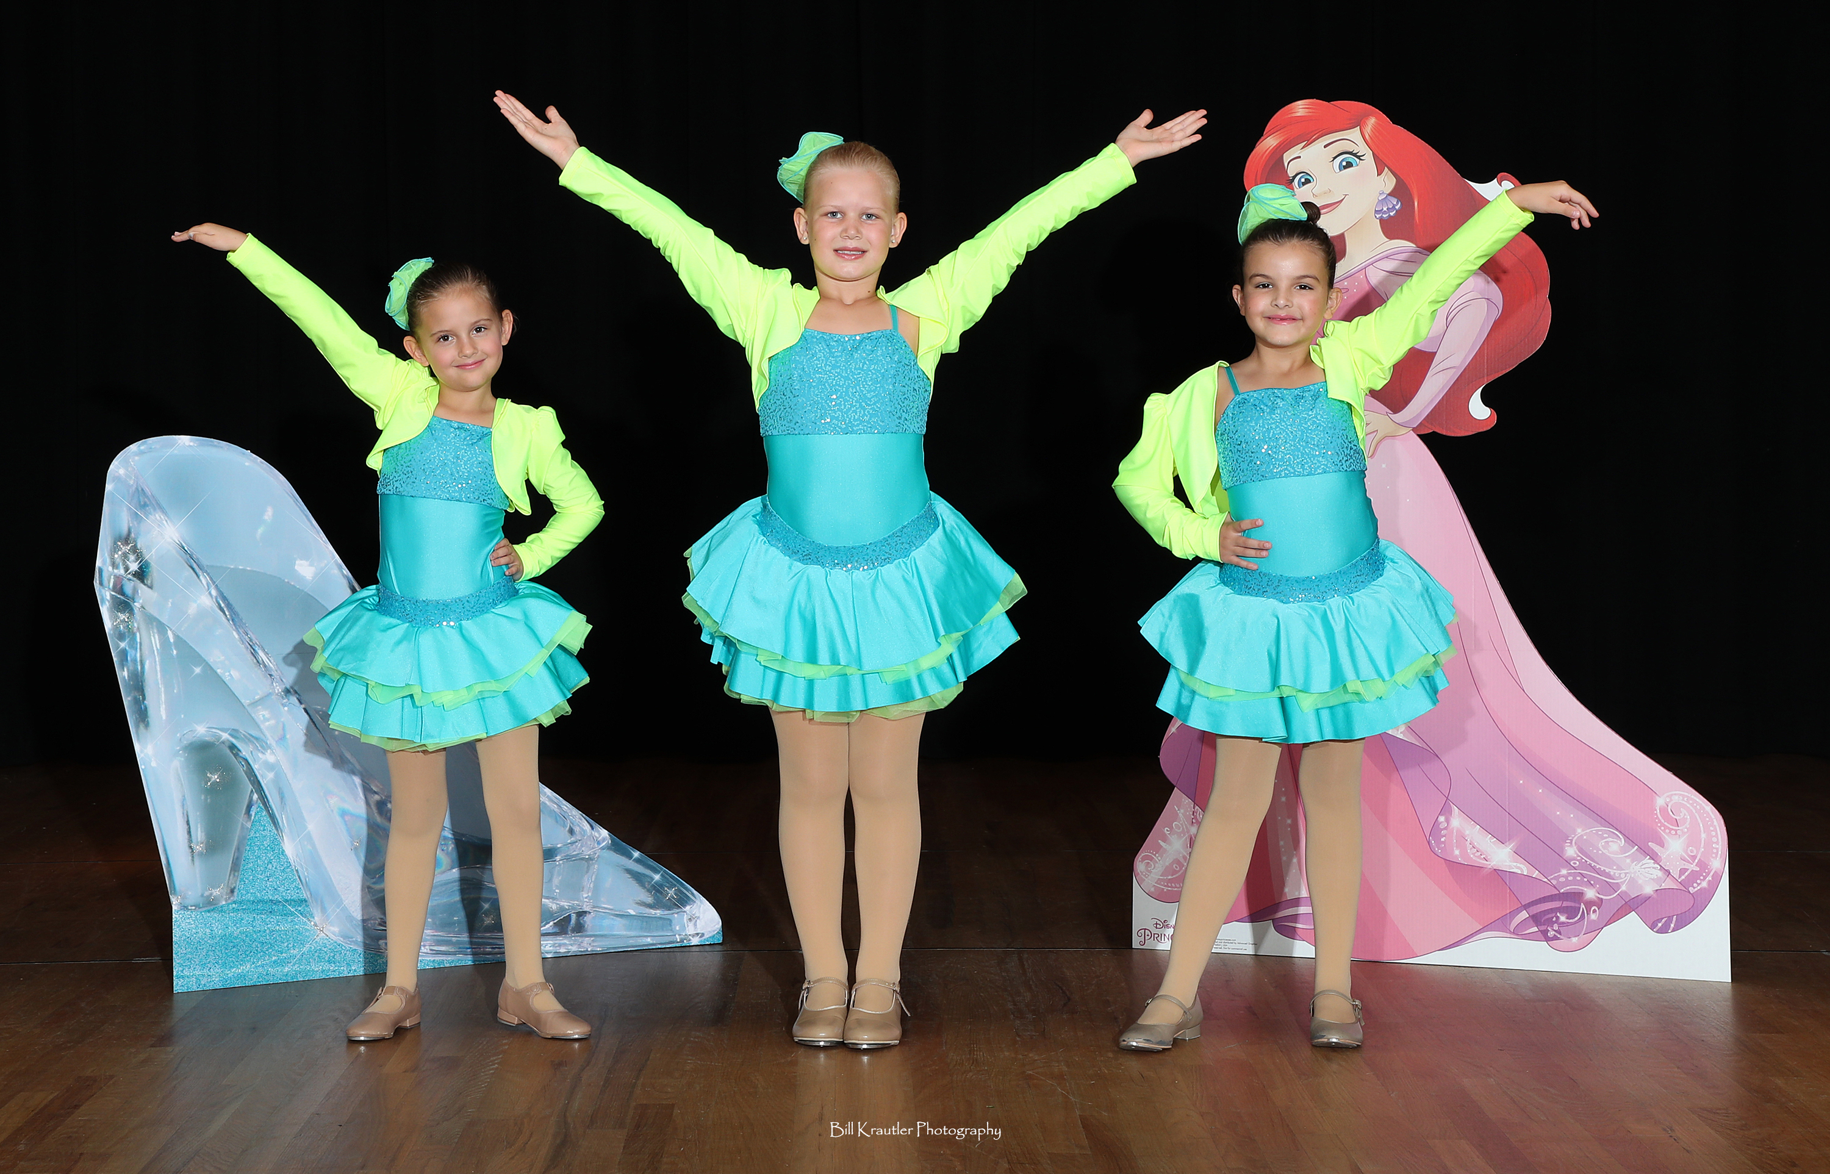

Suncoast Dance Academy

Curriculum

Jazz
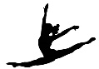
Jazz is a style of dance that finds its roots in ballet, but was enhanced by musical trends, social dances, and the popularization of dance through movies and musicals. It can be percussive with intricate rhythm patterns or fluid with emotional intensity. These classes place an emphasis on isolating body parts, increased flexibility, leaps, turns, and exhibition of individual personality.

Ballet
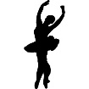
Classical ballet is a style of dance strongly rooted in tradition and discipline. It places an emphasis on lines of the body, precise footwork, and artistically expressive positions of the arms. Students will be taught warm up exercises, ballet positions, vocabulary, barre work, center floor work, and progressions across the floor.

Hip Hop (6 years+)
Hip hop is a high energy class that encourages students to step out of the box by bringing their own individual style and personality to the movements. Different styles of hip hop and movements will be taught in this class. All music and movements are clean and age appropriate.
